Data Provider Information Display

Version: 1.0

September 2019

1368 How Lane
North Brunswick, New Jersey 08902
United States of America
www.enfotech.com

Note: This document may contain information of a sensitive nature. The information is intended for the recipient identified on this Title page and should not be given to persons other than those who are involved in this project.

Document Overview
enfoTech has received information for the 227 Registered Data Providers from DEA, which includes:
- Data Provider Information
  - Data Provider Name
  - GHG Data Provider ID
  - Data Provider Address
  - Contact Person Information
- Facility Information
  - Facility Name
  - Facility Address (Missing for lot of records. Some of them are not in valid format.)
  - Contact Person
  - Activity (IPCC Code) (Note that the IPCC code provided is not 100% match with the IPCC list we summarized during onsite meeting.)

In this document, we will use one Data Provider as example to illustrate how the imported data will be shown in the front end.

Steps to Register the Data Provider
Although the 227 Data Providers has registered with DEA, they still need to go into the SAGHGRS system and fill the “Register New Data Provider Form.” SAGHGRS will auto-populate data based on the information received so as to reduce data entry. Please see the following steps to see how it works.

Step 1 - Register Account
- The ACO of the Data Provider will need to register an “ACO” public user account in the system.
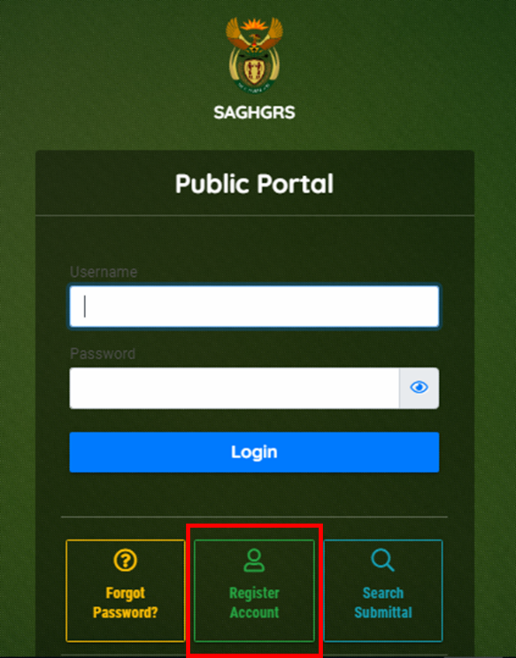

Step 2 – Submit Register New Data Provider Form
- Find the “Register New Data Provider” Form on the public user dashboard/ “Start New Submittal” module.
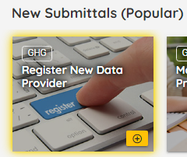

- Choose the Link Data Provider Option, and enter the Data Provider Transfer Code. enfoTech will generate the Transfer Code Internally and send to the ACO’s account. For illustration purpose, some of the Example Transfer Code are listed below.
  - 170500101 Olde World Foundry CC -> Transfer Code = “101TC”
  - 170500102 Pandrol SA (Pty) Limited -> Transfer Code = “102TC”
  - 170500103 Parmalat South Africa -> Transfer Code = “103TC”
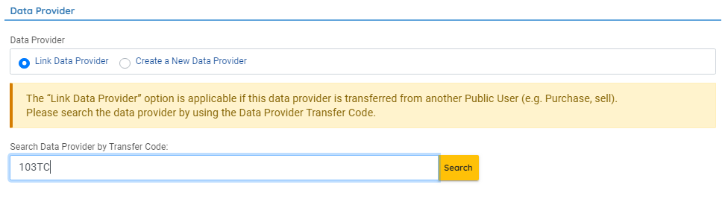
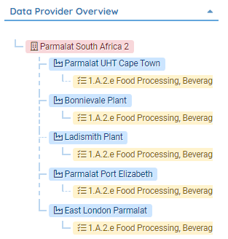
- After entering the Transfer Code, click the “Search” button next to it. The system will populate the information from the database. ACO user will need to enter the missing information before submission. User can also see the populated information from the tree view on the right hand side.

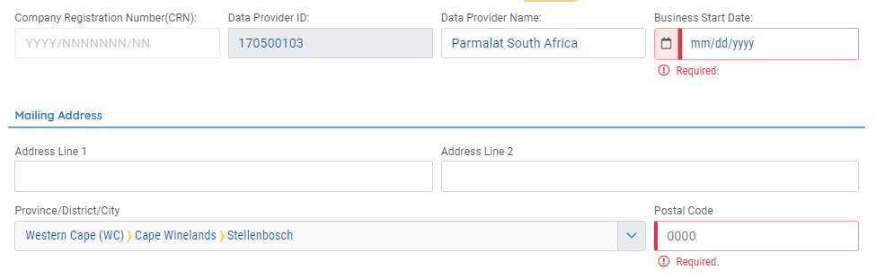
- ACO can click on the “Facility Association Page” and see all the facilities under this Data Provider. The Facility records auto-populated based on the information provided. ACO will also be able to add and delete the facility records.
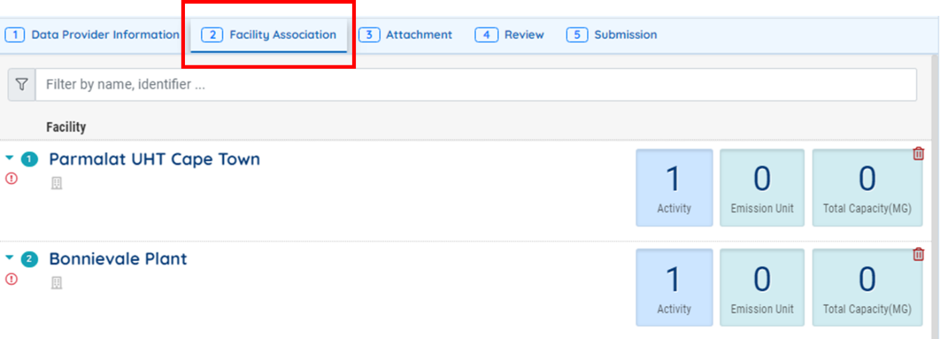

- ACO can expand the facility records and fill in the missing information for this facility.
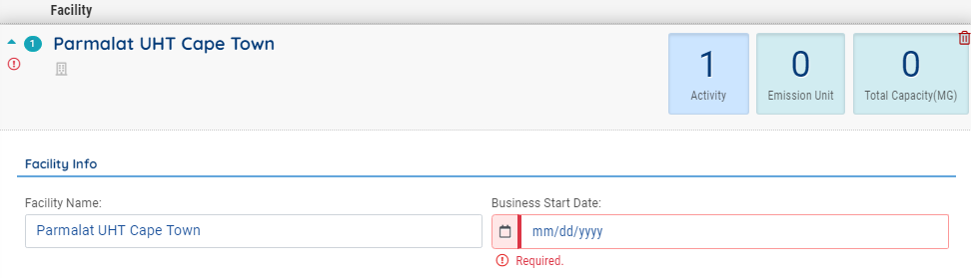

- Under each facility, system will populate the activity information for the facilities. ACO can keep editing the activity information.
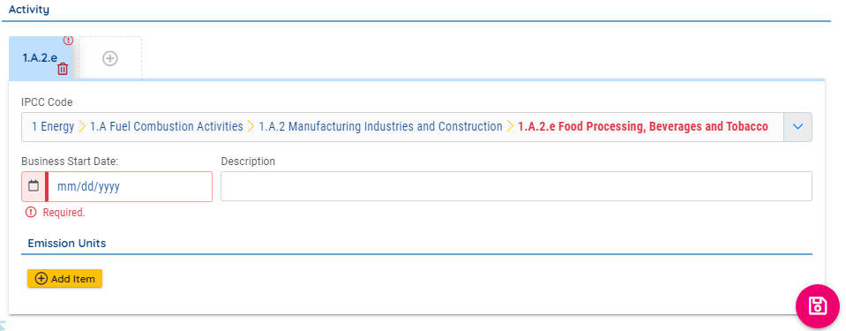

- After entering all the required information, ACO can submit the “New Data Provider” form. Similar to other New Data Provider, they will need to wait for Agency’s approval on the submittal.

